

Séminaire 1

Mercredi 29 novembre 2023, 15h30-17h30 Amphi 3 et Teams:

Invité/ Guest Speaker : **Dr. Adrian Wisnicki (University of Nebraska-Lincoln)**

**VICTORIAN VOICES**

Modératrice/ Chair  **Laurence ROUSSILLON-CONSTANTY (Laboratoire ALTER, UPPA)**

# Respondent : Daný VAN DAM (Centre for the Arts in Society, Leiden University)

Adrian S. Wisnicki is an Associate Professor of English and Faculty Fellow of the Center for Digital Research in the Humanities at the University of Nebraska-Lincoln. He is a founding developer of *Undisciplining the*

*Victorian Classroom*, lead developer of *One More Voice*, and director of *Livingstone Online*. He is also the author of *Fieldwork of Empire, 1840-1900: Intercultural Dynamics in the Production of British Expeditionary Literature* (Routledge, 2019) and various articles in Victorian, African, and Postcolonial Studies as well as the digital humanities.

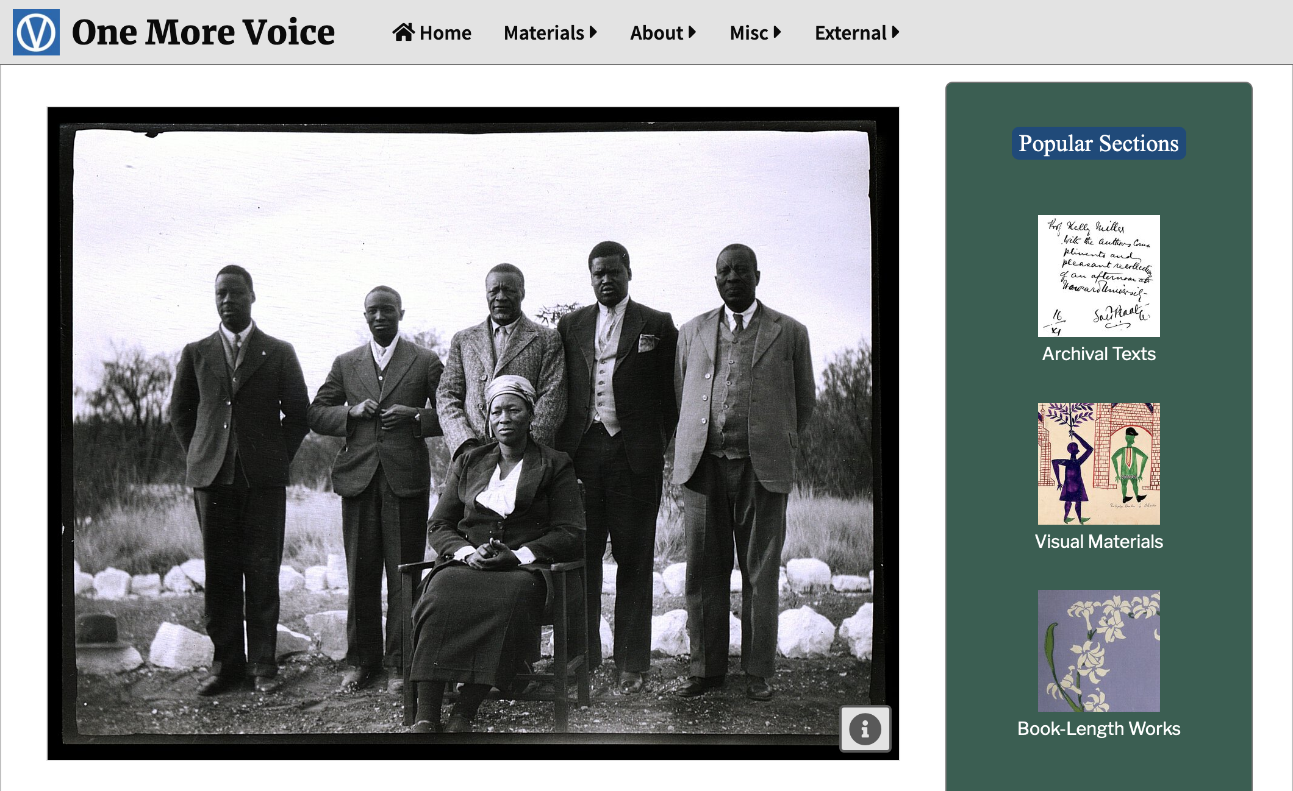

Voices:

# A Seminar Series

Si vous souhaitez plus de renseignements, merci de vous adresser à l’organisatrice: [laurence.roussillon-constanty@univ-pau.fr](mailto:laurence.roussillon-constanty@univ-pau.fr)